BUS Detail Design

DOC. No.: | REV.: 00 |  |  | PRODUCT:
TITLE: BUS Detail Design |  |  |  | Project:
Prepared by: | Donald huang |  |  | Date:
Remark: | Approval:
Remark: |  | Department | Title |  |  | Signature
Remark: | 1 | Electronic R&D
Remark: | 2
Remark: | 3
Remark: | 4

Revision | Description of Change | Author | Date
00 |  | Donald Huang | 4/10/2009

1. Overview 4
1.1. Objective 4
1.2. Scope 4
1.3. Reference 4
1.4. Abbreviations 4
2. Architecture 4
3. Physical Buses 4
4. Classes 5
5. Message flow 6
5.1. Synchronic messages 7
5.2. Asynchrony messages 8
5.3. Call back messages 8
6. Protocol 8
6.1. Request/reply message package 9
6.2. Marshal data format 9
7. Commands 10
Appendix: Compare with SL platform bus 11

Overview

Objective

Scope

This document describes the SL15 serial bus.

Reference

Abbreviations

Architecture

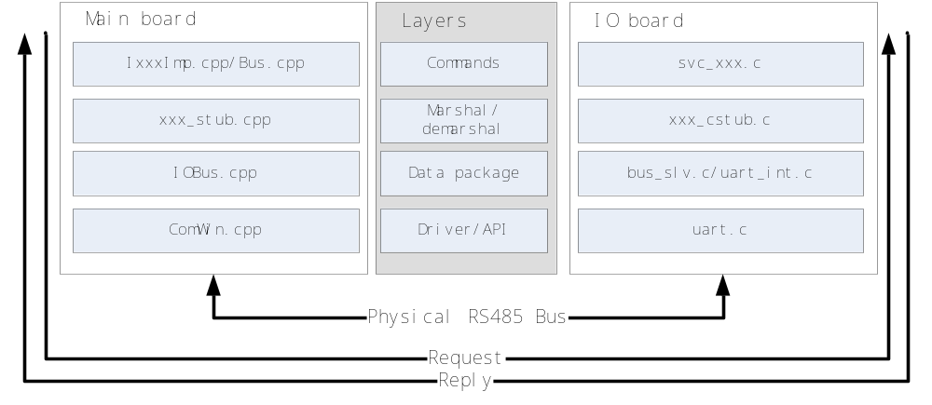
As the above figure shows, both main board and IO board have corresponding bus modules. Main board use C++ language and IO board use C language.

There are 4 layers for both sides. With message flow: request will go from main board’s commands layer to driver layer then from IO board’s driver layer to commands layer; vice versa for respond.

All functions run synchronized in one thread/task.

Physical Buses

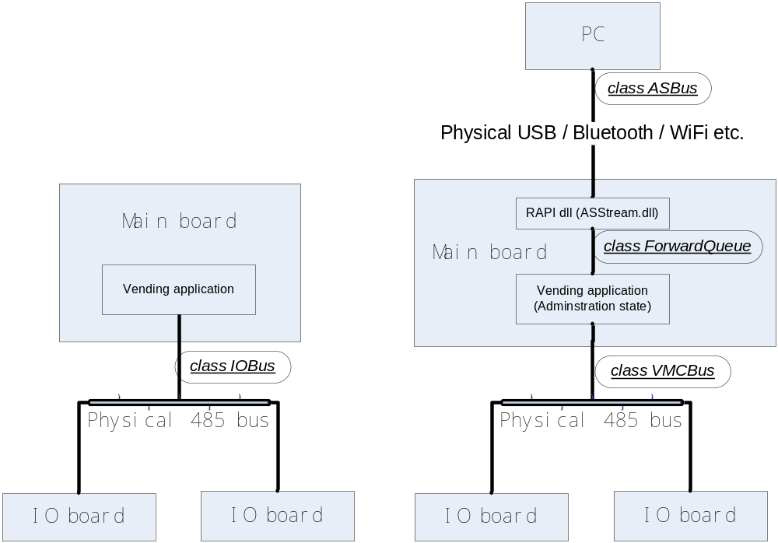

As the above figure shows, there are two way bus runs:
- standalone (left)
- PC connected, the administration status (right)

Main board connects to IO boards with RS485 bus.

PC connects to main board with USB/Bluetooth/WiFi, etc. With Windows CE ActiveSync, the PC application can connect to the main board with RAPI regardless the physical bus connection.

When PC connected to main board, PC application will fully control the machine. Any messages between main board and IO boards will forward to PC.

Classes
There are several Bus relative classes as the following figure shows:

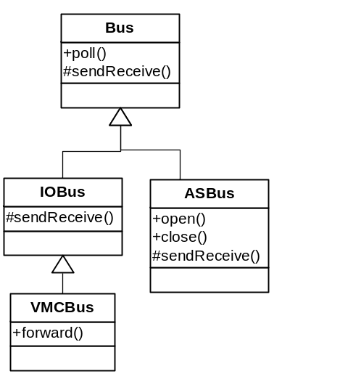

- Bus: abstract class managing high level message and polling.
- IOBus: 485 protocol handling class, used in standalone mode.
- VMCBus: use IOBus to forward messages.
- ASBus: bus using ActiveSync RAPI

There are two more class and call back functions to forward message between PC and main board
- ASStream.dll: RAPI call back functions to forward message between ActiveSync and vending application.
- ForwardQueue: queues used to communicate between RAPI stream dll and PC application.

Bus relative classes and asstream.dll is in http://10.10.0.45/source/trunk/GVMC/BUS

Unit test projects are in http://10.10.0.45/source/trunk/GVMC/test/testBus

Bus between IO board and small board

Architecture
Simulate with the architecture of the main board and IO board, the architecture is showed as below:

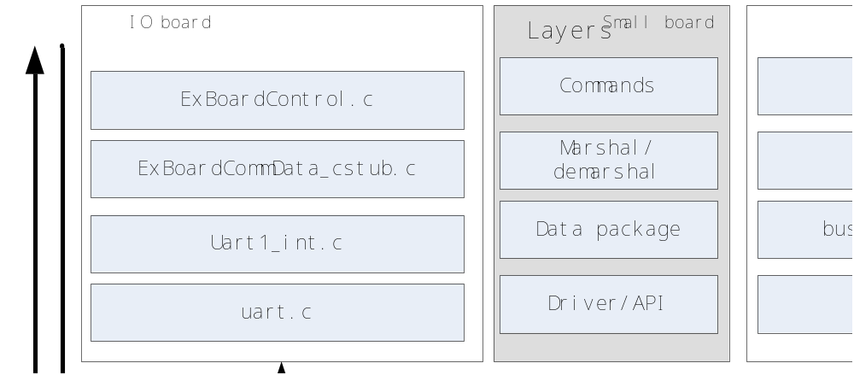

Figure : Architecture

Both IO board and small board use C language. Request will go from IO board’s commands layer to driver layer then from small board’s driver layer to commands layer. vice versa for respond.

All functions run synchronized in one thread/task.

Physical Buses
The IO board connects to small boards with RS485 bus.
For the IO board, IO board connects with main board using UART0,and connects with small board using UART1.
For the small board, small board connects with IO board using UART1.
The physical connection as show below:

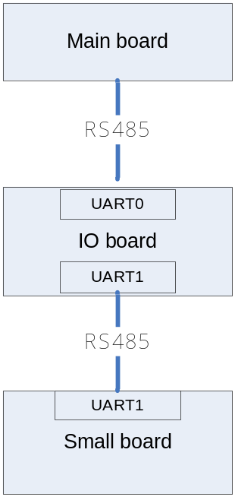

Figure : Physical Bus

Compatibility Design
As mention before, the connection between each board are all using RS485, and using the same protocol (see chapter 7), so some source about communications can be share for each, below describe how to implement that:
- All ports are working in interrupt mode;
- Define macro “ _SMALLBOARD_” to differentiate IO board and small board;
- UART0 of IO board and UART1 of small board are both working as slave, they have the same protocol ,so use the same source Uart.c, Uart_int.c and isrs.s;
- In IO board,UART1 work as master ,witch sends command to small board, while in small board UART1 work as slave only , so IO board use the source Uart1_int.c unique;
- For UART1,when an interrupt take place , IO board and small board will go different interrupt entrance :
IO board : Uart1_int.c\ExBoardUart1RXInt,receive the reply data from small board;
Small board: Uart_int.c\uart1_rx_int,receive the request data from IO board.
See the source file isrs.s;
- Small board does not use UART0.

Message flow

Because the 485 bus is not duplex, the bus can only be occupied by one way message. The protocol has to be run in request-reply mode (main runs as master, IO runs as slave).

Synchronic messages
Synchronic message is message reply at once, as the following figure shows:
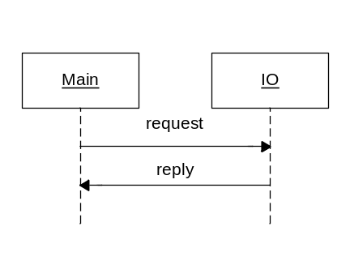

For SL15 IO board synchronic commands are:
- Get and set adjustments
- Send key
- Get components test functions’ information
- Get cup status, close auto door
- And more…

Asynchrony messages

Some time consuming task can not return at once, the asynchrony messages are needed, as the following figure shows:
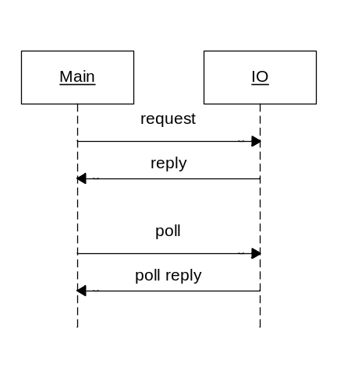

For SL15 IO board asynchrony messages are:
- Run test functions
- Make products
- And more…

Call back messages

IO board can not directly send message to main, these call back messages must return as reply message of poll as following figure shows:
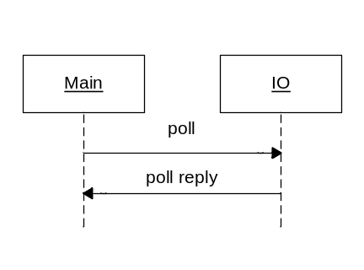
For SL15 IO board call back messages are:
- Report string
- Error messages
- Trace messages
- Require keys buttons for test
- And more…

Protocol

Request-Reply messages are series of bytes, how to marshal/demarshal these bytes is protocol.

All bytes are in network endian.

There are two level of protocol: Request/reply message package and marshal data format.

Request/reply message package

All package no greater than 4K.

Request message package format:
- 1 byte Board id
- 1 byte control
- 2 bytes request id
- 2 bytes date length
- n bytes request data
- 1 byte XOR checksum

The control byte is for sequence and compatible control
- lower 4 bit is always 0x7
- higher 4 bit is for sequence, 0 is for the first request, the following request is 1-0xf incremental div (no 0)

Sequence is the mechanism to hold the consistency of a request/reply. The communication might fail sometime, retry is needed. Yet the status of previous message is unknown to the slave. The incremental sequence makes two requests different, when slave get and request, it will check the sequence, if the sequence is the same as previous one, send the previous reply again.

XOR byte is for the whole request or reply, including everything except XOR byte itself. When slave found the XOR is wrong, it will send back a reply with E_WRONG_XOR as return code, the master should resend request again. The same does the master get the wrong reply XOR.

Reply message package format:
- 2 bytes return code
- 2 bytes data length
- N bytes reply data
- 1 byte XOR checksum

If the reply message is poll return data, the data field will be 2 bytes message id and poll messages (poll message length=data length - 2)

Marshal data format

The request/reply data field stores the real data.

The marshal/demarshal of the data is utilized by IDL:

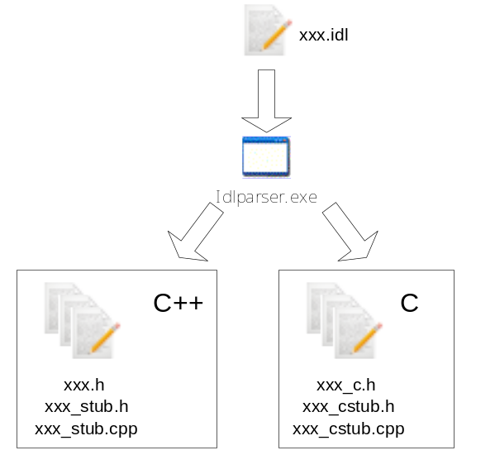

As the above figure shows, data format is defined by an IDL file. idlparser.exe will generate the C++ and C stub files. Application use stub file to marshal and demarshal data.

The IDL grammar definition is in:http://10.10.0.45/source/trunk/public/protocol/idl.txt.

Idlparser.exe source code is in: http://10.10.0.45/source/trunk/utils/idlparser.

Using IDL has following advantages:
- Strong type data format;
- No byte order and data packing problem;
- Cross language and cross platform data format.
- Dynamic length data, data is more compact.

The shortage is more memory and code space is needed (several Kbyte).

Commands

A request/respond pair is packed into a command. For master: main board and PC applications, commands are defined in interface Ixxx.h and implemented in IxxxImp.cpp.

Appendix: Compare with SL platform bus

Asynchronous vs. synchronized:

The SL platform bus works in asynchronous way. It has similar layer architecture, but each layer is implemented in tasks (threads). That means each layer handles its own job and passes data to next layer. However, this leads to the request will not get the reply in determinate time, as the following figure shows:
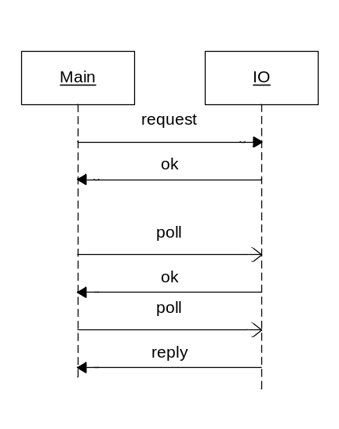
The reply will return by polling, but which the polling after request is uncertain. So the master might keep states and analyses polling reply. If something goes wrong with the communication, a reset command will send to IO board.

No marshal/demarshal

There is no marshal and demarshal for transmit data. Data are defined in packed C struct.

Compatibility consideration

The following points are SL15 software’s task to make SL15 platform BUS compatible with SL platform bus:

- A SL bus protocol layer.
- Asynchronous support: a state machine will need to be implemented in master to achieve asynchronous calls. The calling and polling method need to be re-implemented.
- The high level commands will need to be re-implemented.

For the latest point, following aspects need to be considered:
- There are no SIH/DBH/DBL etc. interfaces
- The component interface is different. Adjustments, MDF, recipe, etc. is stored in main board; the test interface is different (defined in http://10.10.0.45/source/trunk/SVMC/component/CompMgr.h) Most component interface in SL platform is implemented by other way.
- There is no OSH remote menu in SL platform, operator menu is implemented in main board.
- A PC can be plugged in to fully control the whole system. Yet it works different from the CL-serv, all component tests and adjustment edit must be controlled by PC.

